

LAB ASSIGNMENT – 2

Date-August 01,2019

CSN-361(Computer Networks Laboratory)



Submitted by

Abhishek Kumar

Enrollment No. 17114005

BTech. Computer Science and Engineering (3rd Year)

**PROBLEM STATEMENT 1:** **Write a socket program in C to connect two nodes on a network to communicate with each other, where one socket listens on a particular port at an IP, while other socket reaches out to the other to form a connection.**

**ALGORITHMS USED** :

● CLIENT SERVER MODEL ALGORITHM (for client and server as shown):

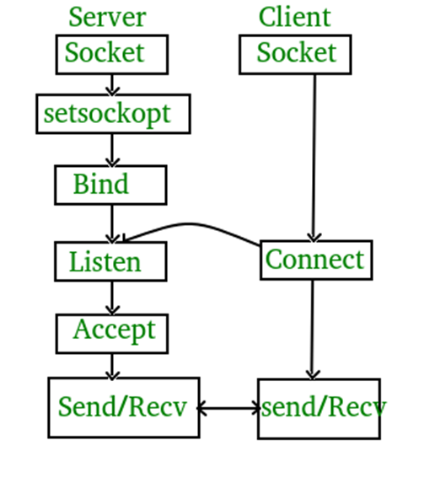

1. int sockfd = socket(domain, type, protocol)
2. int setsockopt(int sockfd, int level, int optname, const void *optval, socklen_t optlen);
3. int bind(int sockfd, const struct sockaddr *addr, socklen_t addrlen);
4. int listen(int sockfd, int backlog);
5. int new_socket= accept(int sockfd, struct sockaddr *addr, socklen_t *addrlen);
6. int connect(int sockfd, const struct sockaddr *addr, socklen_t addrlen);

**DATA STRUCTURES USED** :

**● Int, char *, char []:** To store the socket , strings, buffer

● **struct sockaddr_in :** for storing the port number and creating an instance of client and serve

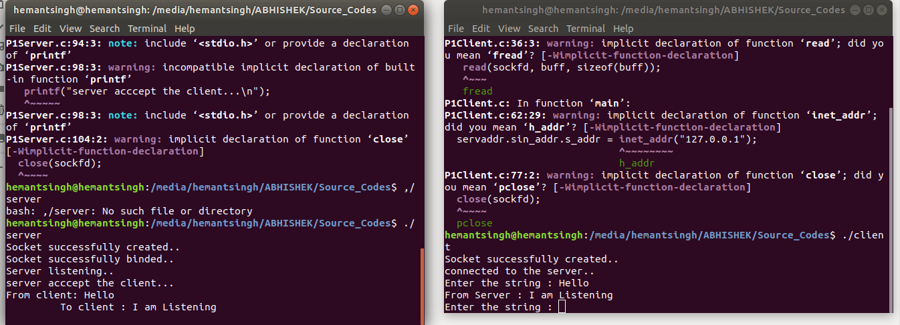

**PROBLEM STATEMENT 2:** **Write a C program to demonstrate both Zombie and Orphan process.**

**ALGORITHMS USED :**

● **fork() :** To create new child

● **sleep() :** For proper functioning of the program

● Busy Waiting

**DATA STRUCTURES USED :**

**● Int,** To store the return value of fork() in it

